Regression Testing:
Regression testing is re-running functional and non-functional tests to ensure that previously developed and tested software still performs after a change. If not, that would be called a regression
Regression Testing is defined as a type of software testing to confirm that a recent program or code change has not adversely affected existing features. Regression Testing is nothing but a full or partial selection of already executed test cases which are re-executed to ensure existing functionalities work fine.

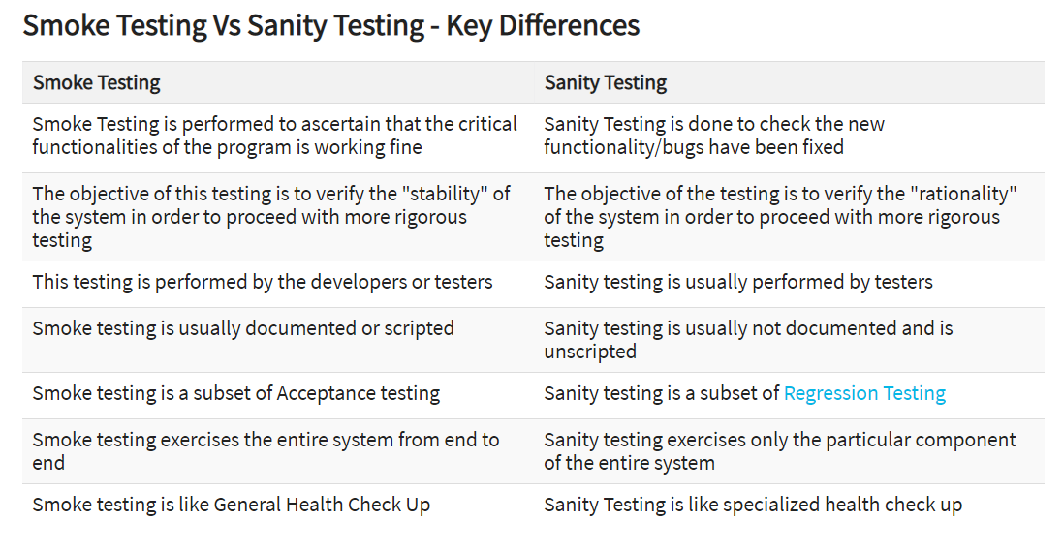

Agile Methodology:

In agile methodology, software is released in small iterations. Each iteration goes through planning, estimation, development, integration, testing and release. Because of frequent releases, test automation becomes ever so important as developers need to get quick feedback on the status of the application. The automated checks serve as regression tests to ensure that with each release the software has not regressed.

Testing concepts:
Exploratory Testing is an important activity in an agile environment as it can help software testers to keep up with the rapid development pace of agile software projects.
First, a brief intro on agile methodology and exploratory testing:
In agile methodology, software is released in small iterations. Each iteration goes through planning, estimation, development, integration, testing and release. Because of frequent releases, test automation becomes ever so important as developers need to get quick feedback on the status of the application. The automated checks serve as regression tests to ensure that with each release the software has not regressed.
Exploratory Testing is defined as simultaneous learning, test design and test execution.
Exploratory Testing is also complementary to test automation; that is while automated checks are checking for regression issues, Exploratory Testing focuses on new features which have been developed. This is important because each sprint typically lasts only couple of weeks, which doesn’t allow sufficient time for scripting tests cases and executing them later against the application. On the other hand, exploratory testing in agile environment allows testers to get familiar with the domain and the application and on each iteration, that understanding is enhanced and hence testers become more efficient.
Exploratory Testing is an important activity in an agile environment as it can help software testers to keep up with the rapid development pace of agile software projects.

Important points:
Exploratory Testing is an important activity in an agile environment as it can help software testers to keep up with the rapid development pace of agile software projects.
In agile methodology, software is released in small iterations. Each iteration goes through planning, estimation, development, integration, testing and release
Exploratory Testing is defined as simultaneous learning, test design and test execution.

Automation Challenges:
Testing always under time constraint
Requirements keep changing
Effective Team collaboration
Choosing the right tool
Skilled resources for the Automation

Defect Life Cycle:
New, Assigned, Open, Fixed, Retest, Verified and Closed.
Retest→Reopen
Open→Deferred, Duplicated, Rejected and Not a Bug.
STLC Life Cycle?
Requirement Analysis
Test Planning
Test case development
Test Environment setup
Test Execution
Test Cycle closure
Explain Entry and Exit Criteria?
Examples for Entry Criteria:
Verify if the Test environment is available and ready for use.
Verify if test tools installed in the environment are ready for use.
Verify if Testable code is available.
Verify if Test Data is available and validated for correctness of Data.
Examples of Exit Criteria:
Verify if all tests planned have been run.
Verify if the level of requirement coverage has been met.
Verify if there are NO Critical or high severity defects that are left outstanding.
Verify if all high risk areas are completely tested.
Verify if software development activities are completed within the projected cost.
Verify if software development activities are completed within the projected timelines.
How a tester should be?
Testing the application through customers eye.
Tester should think ‘Out of the box’.
Testers job is not only finding defects in the software, but also to improve the quality of the product.

Difference between Test Strategy and Test Plan?
Test strategy is a high level document which defines the approach for software testing. It is basically derived from the Business Requirement document. Test strategy is developed by project manager or business analyst. It is kind of static document which sets the standards for testing so not updated often.
Test plan is derived from SRS (Software Requirement Specification) which is prepared by test lead or manager. The main goal of test plan is to include all the details related to testing such as what to test, when to test, how to test and who will be the tester. Test plan is often not updated but if there is some new feature or change is introduced then it has to be updated accordingly.
What are Test Deliverables?
Test cases Documents, Test Plan, Testing Strategy, Test Scripts, Test Data, Test Trace-ability Matrix, Test Results/reports, Test summary report, Install/config guides, Defect Report and Release notes

